

Argupedia

6CCS3PRJ – Individual Project

April 2020

**Author: A K M Naharul Hayat**

**Student Number: 1750583**

**K Number: K1764014**

**Supervisor: Dr. Sanjay Modgil**

Originality Avowal

I verify that I am the sole author of this report, except where explicitly stated to the contrary. In addition, I confirm this report does not exceed 25,000 words.

A K M Naharul Hayat

April 2020

Acknowledgements

I would like to thank my supervisor, Dr. Sanjay Modgil, for providing me the right guidance to see this project through to the end. Without his support and supervision, it would not have been possible.

Abstract

Since the dawn of the information age, people have turned to debates online to understand both sides of an issue and subsequently, form a viewpoint based on their interpretation and comparison of the two sides. Majority of existing online debate platforms allow participants to engage freely in the form of text, without enforcing any structure. While this does have its advantages, it however, in practice, often results in debates where participants propose actions and make assertions without justification and rationalization behind them. This coupled with the fact that discussions can easily expand to a large number of pages, makes it difficult for new individuals looking to jump in and understand the different positions involved and whether or not the respective positions are regarded as accepted.

This project aims to build and evaluate an online application which aims addresses the issues by deconstructing typical structure of rational arguments in debates and researching ways we can incorporate it in the application to ensure debates remain focused. Secondly, it aims to visualize debates, so it is easy to keep track of its evolution, with the added benefit of the user not having to go through pages of texts. Finally, it focuses on exploring theoretical notions of classifying positions in debates and integrating it in the application to enable users to know at a glance which arguments are regarded as accepted at the current stage of the debate.

Contents

1. Introduction 7

1.1 Background and Context 7

1.2 Defining the Problem 7

1.3 Closer Look at Existing Solutions 8

1.4 Goals and Objectives 9

1.5 Conclusion 9

2. Background & Literature Review 9

2.1 Modelling Atomic Argument Structure 10

2.1.1 Walton’s Argumentation Schemes 10

Appeal to Expert Opinion [19] 10

Argument from Position to Know [19] 11

Appeal to Popular Opinion [19] 11

Argument from Analogy [18] 11

Argument from correlation to cause [18] 12

2.1.2 An Extension of Walton’s Scheme 12

Action Scheme 13

2.2 How argumentation scheme can be used to address the problem 13

2.3 Modelling debates using argumentation schemes 14

2.4 Labelling accepted arguments at a given state of a debate 15

2.4.1 Abstract argumentation theory of Dung 15

Foundation of dung’s argumentation framework 15

Argument defence 16

Conflict Free Sets 16

Admissible Sets 16

2.4.2 Semantics of Acceptance (Extensions) - Dung’s Argumentation Framework 17

Complete Extension 17

Grounded Extension 17

Preferred Extension 17

Stable Extension 17

2.4.3 Credulous and sceptical acceptance 18

2.5 Modelling debates as Dung’s argumentation framework to facilitate labelling 18

2.5.1 Modelling using Argumentation Schemes 18

2.5.2 Modelling using textual entailment 20

2.5.3 Argumentation Schemes vs Textual entailment 20

2.6 Evaluation of Semantics of Acceptance (Extensions) 20

2.7 Grounded Extension Labelling algorithm 21

2.7.1 Pseudocode 22

3.0 Requirements 22

4.0 Specification 23

5.0 Design 25

5.1 Use Case 25

5.2 Project Solution Nature 27

5.3 Application Architecture & Justification 27

5.4 Database Schema & Entity Relationship Model 29

5.4.1 Justification of Database Design 30

5.5 State Machine 31

5.6 Important Note 31

6.0 Implementation 31

6.1 Development Methodology 32

6.2 Key Implementation Decisions 32

6.2.1 Development Framework & Technologies 32

6.2.2 Database Layer 33

Model Classes 33

How models were implemented to provide value 33

6.2.3 Presentation Layer (Front-end) 34

Using template language to ensure front-end logic is easy to maintain 34

Bibliography 35

# 1. Introduction

## 1.1 Background and Context

Being one of the oldest internet services, online discussion forums to this day continue to stand out in terms of popularity. This is evident from the fact that popular online discussion platforms such as Reddit and Quora have over 300 million active user bases [1, 2] with the former ranking in top 20 in terms of popular sites on the internet [3].

The user generated content nature of such platforms allows its users to not only have discussions about a topic, but also have debates about pressing issues around the world and exchange idea and opinions by posting and replying to critique each other’s comments/posts.

Debates at its core involve critiquing and presenting reasoning behind a proposed action or view, in order to justify it. Observing debates from this point of view enables us to consider its potential outside of mere online discussions. As noted by researchers in the field [4], debates can be evaluated and used by political leaders as a method for gathering public opinion and their reasoning - for and against a particular proposed policy or an issue. In addition, it has the potential to enable general public to observe a debate and have a well-informed educated opinion about a topic or an issue they lack knowledge about. Furthermore, it encourages them to analyse a proposed argument critically.

This project aims to build an online debate platform with the goal of realizing full potential of online debates as discussed above by addressing key issues with existing debate platforms, which we will discuss in the next section.

## 1.2 Defining the Problem

Having discussed all of the potential uses of debates in the previous section, there exists some issues which prevents the use of debates in existing online platforms to its full potential. These are discussed below:

1. It is often the case that debates end up having a lot of arguments. For example, one of the popular sub-forums in Reddit known as ‘Change my View’, which is strictly debate based, average close to 100 comments per topic [5]. In such long and complicated debates, it is difficult to make sense of which argument is critiquing which argument and reason through the debate and trying to extract the current accepted argument/position in a debate. As a result, making it difficult for individuals to have an informed opinion about a topic or an issue. This could discourage further participant from joining in on debates, because they may feel they do not know enough about the current state of the debate.
2. Existing debate platforms allow people to engage in debates by claiming a fact without backing it up with accepted ways of reasoning to reach the claim as the conclusion. This further adds to the difficulty of reasoning through a debate to a conclusion as it involves jumping through arguments which do not truly contribute to debate (i.e. arguments which are not backed by facts/reasoning/justification).
3. Existing online debate platforms focus on popularity of arguments/comments and favours them in terms of visibility, hence are generally considered as accepted argument in the debate. However, this has the potential of introducing bias in a debate. As noted by Scott in his book [7], people often tend to fall victim to confirmation bias, which is the tendency to favour information in a manner which tends to support one’s previous belief. Participants in a particular forum, may be biased towards a particular area, therefore, only voting positively for arguments which confirm their bias and negatively to the ones which do not. This in turn diminishes the chance of arguments which are against the bias to be noticed by public, despite being perfectly valid. There-fore, individuals exploring a debate topic to form an informed opinion, may only notice the arguments which favour bias and interpret them as accepted. Furthermore, perfectly valid arguments may not get the recognition it deserves just because it was posted at an inopportune time (later in the debate) as a result failing to get votes.
4. Online debates do often times get a bit heated. In such situations, it is observed people often ridicule contributions proposed by opposition, thus negatively affecting the overall debate as well as the motivation of participants. A study in the field regarding experiences of people participating in online forum and communities [6] suggests that close to 4% of participants encounter bullying. Although the figure may seem quite small, however, it is worth noting that public forums are a community as a whole, this could have an impact on other participants indirectly and dissuade them from engaging in debates in a healthy manner. However, the impact of this is yet to be evaluated.

## 1.3 Closer Look at Existing Solutions

There however exists online platforms such as ‘Debatepedia (www.debatepedia.com)’ and ‘Kialo (www.kialo.com)’, which although less popular than the ones mentioned before, attempts to address some of the problems mentioned above. Both of these platforms groups arguments in the form of pros and cons which allows users to easily weigh both sides of an issue/topic. In addition to this, ‘Debatepedia’ allows users access to detailed background information about a topic. ‘Kialo’ on the other hand also allows users to dive into sub-debates regarding a main topic in order to enable user to focus on targeted discussion. Furthermore, it allows visual representation of a debate in the form of a tree, with the main initial argument being represented as the root node of the tree and arguments which support or attacks it, being represented as child nodes.

However, both of the platforms mentioned allows users to engage in debate without following an accepted reasoning pattern, which opens doors to users engaging in debate by simply stating their claims without reasoning behind how they are reached their conclusion. In addition, ‘Kialo’ for instance, judges the strongest argument and ranks visibility by user votes alone, which, as discussed previously, gives rise to problems such as low visibility of perfectly valid counter-arguments, due to the majority of members having bias themselves or due to the argument being posted very late in the debate leading to lower votes. Furthermore, the platforms do not have a clear concise way of identifying arguments which are currently at an accepting position in the debate.

## 1.4 Goals and Objectives

As discussed in the previous section, majority of current online debating platforms require participants to engage openly in text form. Although this has its benefits in terms of freedom of input, however, in practice, it also leads to discussions where participants engage in debates without accepted forms of reasoning to justify their case. In essence, there is no structure being enforced which incentivize participants to engage in debates using accepted forms of justification and reasoning in everyday life.

The goal is to model typical structures of rational arguments which perfectly encapsulates what we consider as logical form of reasoning in everyday communication, and then, subsequently, enforce or incentivize users to engage in debates using the model.

The hypothesis is that doing so, will result in individual contributions in debates to follow what we consider as accepted form of reasoning. Hence will eliminate the problem of people engaging in debates without proper justification behind their claim. In addition, enforcing such a structure also have the potential of ensuring arguments in debates stay focused and eliminates the scope of the issue of online bullying and ridiculing in debates.

In addition, an exploration towards identifying ‘accepted’ positions of a given state of a debate is needed, however, it must not rely solely votes because of the potential of inflicting bias, as discussed previously. Having a method of classifying individual arguments in debates to identify which of the positions make logical sense will address the issue and make it easier for new participants looking to contribute. Furthermore, it will also ensure people can understand current state of a debate more easily.

## 1.5 Conclusion

Taking into account the points discussed in the previous sections, we can conclude that problems do exist in existing online debate platforms which prevents debates being useful to the full extent of their potential. The aim of this project is to research, develop and evaluate a solution which attempts to address the problems discussed.

The next chapter aims to discuss existing research in the area and evaluate whether it can be used to address the problem, if so, then in what ways we can potentially build on it to cater towards our problem and accomplish the goal discussed in previous section.

# 2. Background & Literature Review

This chapter intends to explore and discuss existing research in the area and evaluate whether it caters towards out goal and problem. If so, we aim to discuss how we can build on it to address the problems defined and whether there are other alternatives as well.

## 2.1 Modelling Atomic Argument Structure

In the initial part of the chapter we will dive deeper into existing research which models atomic arguments in debates, based on logical forms of accepted reasoning in everyday communication. The goal of this chapter is to understand ways we could structure individual arguments coming from both parties in a way such that it encourages justification of points being made.

### 2.1.1 Walton’s Argumentation Schemes

Walton’s Argumentation schemes [19] are structures of arguments which reflects how we reason in everyday conversation exchanges. It defines structure for common types of arguments we use in everyday conversation. The core inference consists of a set of premises followed by a conclusion/claim. Researchers in the area have put forward common argumentation schemes which are regarded as commonly accepted ways of reasoning to put forward a point in conversation. In addition to this, each argumentation scheme consists of its own set of critical questions [19], which reflects the way we normally think critically about a claim. An example of a common argumentation scheme known as ‘Appeal to Expert Opinion’ (taken from source [19] for demonstration) is as follows:

#### Appeal to Expert Opinion [19]

An expert source ‘E’

Who is an expert in subject matter ‘S’

Asserts ‘C’

‘C’ is true

Premise

Claim

Note that the argument is rationally persuasive on the basis that there is a natural tendency to respect an expert but if we look at from inductive reasoning [20] or deductive reasoning perspective [20], it may not be valid, however that is the point of Argumentation schemes as it focus is to capture reasoning in everyday conversation exchanges.

As mentioned previously, each argumentation schemes consist of critical questions. A few example critical questions (taken from source [19]) for the above argumentation scheme is as follows:

* Is expert source really trustworthy?
* Can the expert ‘E’ really be considered an expert in the subject matter S?
* Does another expert make a claim which contradicts with C?

In addition to expert opinion, the following accepted argumentation scheme exists, each with their own structure (considered as rationally persuasive in everyday conversations) and critical questions:

#### Argument from Position to Know [19]

Source ‘S’ is in a position to know about a domain ‘D’

‘S’ asserts or makes a claim about a proposition ‘P’ in Domain ‘D’

P is True

Premise

Claim

Note that the above argument reflects persuasion on the basis that if an entity is in a position where he possesses information about a domain, we normally assume that he is able to make claims which can be regarded as true. For example, a local in an area may be in a position to know about, for instance, nearest supermarket location. Again, such arguments may not have basis with regards to inductive and deductive reasoning, however, argumentation schemes focus on capturing reasoning in everyday communication exchanges.

A few example critical questions (taken from source [19]) for the above argumentation scheme is as follows:

* Is ‘S’ really in position to know in the domain?
* Is ‘S’ a reliable source?
* Did ‘S’ really assert that P is True or False?

#### Appeal to Popular Opinion [19]

Premise

A large majority of people accept argument ‘A’ as true.

If ‘A is generally accepted, that gives reason in favour of ‘A’

There is a reason in favour of ‘A’

Claim

Note that the above argumentation scheme reflects persuasion on the basis that if a large majority believe in something, there must be a valid reason in the argument. It is worth noting that Walton himself considers this argument as deductively invalid, however, it perfectly captures the perception of an argument which is widely believed to be true in everyday life.

A few example critical questions (taken from source [18]) for the above argumentation scheme is as follows:

* What verification is there to support that ‘A’ is generally accepted?
* Does any other evidence go against ‘A’?

#### Argument from Analogy [18]

Generally, two cases – Ca andCb are similar

Argument ‘A’ is true (or false) in case - Ca

Therefore, ‘A’ has a high chance of being true in Cb as well

Premise

Claim

The above argumentation scheme reflects persuasion on the basis that if two situations are similar and an argument is true in one of them, then there is a high probability of it being true in the second situation as well. It reflects how we reason in everyday life based on existing examples which are similar to the one in question.

A few example critical questions (taken from source [18]) for the above argumentation scheme is as follows:

* In case Ca, does the argument ‘A’ really hold?
* Is case Ca and Cb, similar in the right way to assume ‘A’ will hold true in Cb as well?
* Is there a third case – Cc, which is similar to Cb and Ca in which the argument does not hold?

#### Argument from correlation to cause [18]

Historical data/past experience ‘H’

Suggests a positive (or inverse) association between A and B

Therefore, ‘A’ causes (or inverses) ‘B’

Premise

Claim

The above argumentation scheme reflects persuasion on the basis of data suggesting one thing leads to the other. It reflects out reasoning based on past experience and confirmation bias [7].

A few example critical questions (taken from source [18]) for the above argumentation scheme is as follows:

* Is there really a correlation between A and B? If so, was the method used to establish the relation valid?
* Is there any explanation which suggests that the correlation may have been a coincidence?
* If there a third element that triggers the correlation?

### 2.1.2 An Extension of Walton’s Scheme

As pointed out by researchers in the field [21], the initial debate basis consisting of the proposal should start on a note which captures the following:

* A straightforward description of the rationale for a proposed action, which explicitly renders all the components of the logic in support.
* An opportunity to critically evaluate and question – not only the argument, but also relations between the logic behind it.
* A scope of proposing alternate solution or justification.

Although, the previous argumentation schemes discussed, manages to capture everyday reasoning and allows critiquing, however they fail to incorporate all of the points of the initial debate mentioned above.

#### Action Scheme

This leads us to an extension of Walton’s argumentation scheme - known as ‘Action Scheme’ [22] which aims to capture the factors necessary for the initial argument of the debate. Its structure is as follows:

Premise

In situation ‘S’

Doing action ‘A’

Achieves Goal ‘G’

Promotes Value ‘V’

Claim

The action scheme (extended based on Walton’s Schemes) enforces the participant to make the following points, which addresses the characteristics necessary for the initial argument:

* Encourages the person initiating the debate to demonstrate a knowledge of the present situation from his point of view.
* A description of the circumstance that would arise from executing the action.
* Characteristics of the new condition arising from the action which are considered to be appealing.
* The beneficial values which are promoted as a result.

Although the action scheme is particularly well suited for the initial debate argument as discussed. However, it can be used in counter arguments as well, to propose alternative solution, thus, the structure is not limited only to initial argument in the debate.

A few example critical questions (taken from source [21]) for the action scheme is as follows:

* Is the description of the current situation accurate?
* Will the action proposed really achieve the goal?
* Does the goal realize the value?
* Is the value really worth promoting?
* Will the action result have undesirable side effects?

## 2.2 How argumentation scheme can be used to address the problem

If we take a high-level view of argumentation schemes, they have the potential to be used as tools by debaters to make a claim/point. By basing their claim on an argumentation scheme structure, they conform their argument to ways of proposing arguments considered as persuasive and rational in every day communication. Hence both parties can propose their points in a debate by basing them on the structure defined by the schemes.

This leads to the debates being significantly more concise and rational, because each argument has to follow a clearly defined structure, which forces participants to focus on the point and also helps them follow proper accepted ways of reasoning to conclusion in exchanges.

Using argumentation scheme to enforce the use of structured arguments in debates, addresses the problem of online debates having responses which are baseless, or in other words, responses which critique without following proper reasoning/backing with fact, as participants are now forced to structure their argument using argumentation schemes. Moreover, this also addresses the problem of contributors ridiculing each other’s argument as responses have to follow a structure.

## 2.3 Modelling debates using argumentation schemes

In the final part of the previous section, we discussed how argumentation schemes can be used to put forward individual points in the debate by participants.

To elaborate on the idea further; each scheme has their own set of critical questions which have the potential to encourage both parties to think critically about the proposed argument. Subsequently, critical questions can be used as a basis for critiquing the argument by making their own counter-argument, again using one of the argumentation scheme structures discussed. Enforcing the use of critical question as basis of proposing counter argument, helps participants focus on the exact aspect of the original argument he is attacking, which leads to criticisms which are focused.

To illustrate, suppose a participant starts a debate topic using the ‘Action Scheme’ and he proposes the initial argument as follows:

* **In Situation:** Coronavirus spreading around the country resulting in deaths
* **Doing action:** Imposing total lockdown in the country
* **Achieves Goal:** Reduce infection rate
* **Promotes value:** Good health

The argument proposed above is based on the action scheme and can be critiqued using one of the critical questions of action scheme. Suppose another participant comes along and criticizes the argument on the critical question – ‘Action proposed have an adverse side effect’. Subsequently, he can form his own argument on the basis of the critical question. An example counter argument based on ‘Expert opinion’ scheme which critiques the argument above is demonstrated below:

*Critique position:* *Action proposed could have adverse side effect*

* **Expert Source:** Economic research department at ‘Buzzfeed’
* **Expert Area:** Specializes in macro economics
* **Expert assertion:** Asserts that imposing lockdown will result in poverty, as sick leave wages proposed by government is not enough.

To expand the example a bit further, another participant may come along who disagrees with the expert opinion argument above and can critique similarly based on the critical question of expert opinion scheme.

Just to demonstrate an example, the new participant could critique the above argument using any argument scheme he/she chooses. For this instance, let us assume he chose to counter the argument using ‘appeal to popular opinion’:

Critique position: Expert source is questionable

* **Popular claim:** Large majority believe ‘BuzzFeed’ often reports misleading information
* **Assertion based on popular claim:** Research claims from BuzzFeed should be taken with a grain of salt.

Note that the examples above was purely based on fiction and is simply used to demonstrate how a debate based on argumentation schemes and critical questions - may evolve.

There does exist other argumentation schemes devised by researchers in the field. However, for the initial iteration of the project, the aim is to evaluate using the six schemes introduced in the previous section of this chapter.

## 2.4 Labelling accepted arguments at a given state of a debate

As defined in the problems, an exploration towards identifying accepted arguments/positions at a given state of a debate is needed, however, the method much not solely rely on votes, as it has the possibility of inflicting bias.

This brings us to studies in the field of ‘Argumentation Theory which explores dealing with disputable information and applying logical reason in order to reach a conclusion [8]. Several scholars in the field of Artificial Intelligence and Philosophy have researched methods of argumentation and its position in everyday reasoning. This section attempts to explore current knowledge, including empirical observations, and conceptual approaches to labelling positions in debates.

### 2.4.1 Abstract argumentation theory of Dung

A lot of research on the subject of argumentation is focused on Dung’s abstract argumentation frame-work [9]. It is abstract [10] in the sense that its core fundamental is only concerned with a set of atomic arguments coupled with a binary relation of the arguments representing which argument is criticizing/attacking which argument. It does not concern itself with the structure of the arguments or the core meaning behind how it is. However, it is widely used because it is very powerful in the sense that it can be used to deduce and identify set of logically accepted arguments from a knowledge base consisting of simply atomic arguments coupled with binary relation of their attack/criticism relation.

#### Foundation of dung’s argumentation framework

The concept of argumentation framework can be represented visually [11] in the form of a directed graph, with the nodes, depicting the atomic arguments, and the binary attack/criticism relation set being represented as arrows between the nodes. This is represented in an example, inspired by [13], demonstrated below:

*Atomic argument A1:*The cheapest option is to go to the park; therefore, we should go to the park tomorrow.

*Atomic argument A2:*But it is cold tomorrow, therefore we should go to café instead.

*Atomic argument A3:*Forecast says it will be hot tomorrow, so you won’t be cold tomorrow.

This can be represented visually as follows:

Node that an arrow from an argument node, say for instance X to an argument node Y conveys that, X is attacking argument Y [11]. In the example above, A1 is attacking A2 and A2 is attacking back as well. This is because A2 is criticizing A1 [13], backed by the reasoning that “it is going to be cold tomorrow”, how-ever, A1 is attacking back as well because it is claiming the opposite of A2, and is also backed by the rea-soning that “it is the cheapest option”. Note that A3 is attacking A2 on its claim that it is going to be cold, backed by reasoning of weather forecast, however, A2 is not attacking back [13] in this case because its claim – ‘it is going to be cold tomorrow’, which is being attacked, is not backed by any reasoning. Hence in this case it is a one directional arrow.

The argumentation framework for the example above can be formally defined as:

Atomic Arguments = {A1, A2, A3}, Attack Relation = {(A1, A2), (A2, A1), (A3, A2)}.

#### Argument defence

The concept of argument defence is illustrated below [13]:

Argument set Y (blue) defends argument X (green) as it attacks every attacker of X (orange). It is worth noting that if an argument is not attacked, it is defended by all sets [13].

#### Conflict Free Sets

An argument set is said to be conflict free [11] if none of the arguments in the set attack each other. I.e.: they are not conflicting. For instance argument set {a, b, c} is considered conflict free if there are no arrows between a, b, or c (no attack between each other each other or no bad blood in the set of arguments).

#### Admissible Sets

In essence, admissible sets [14] are sets of argument subsets, which are self-defended. In order to compute admissible sets, we take the following steps:

1. We take the power set of all arguments. For example, if we had only arguments A and B in the graph, the powerset would be: {(a), (b), (a, b)}.
2. Once we have the powerset, we eliminate the subsets in the powerset which have conflict, and only keep the ones which are conflict free. In the example above, if there is an arrow from a -> b (a attacks b), as in the set (a, b) is not conflict free, we eliminate it from the set of powerset.
3. For each subset in the filtered set in step 2:
   * If an argument in the subset is attacked, it must be defended by the arguments in the subset itself for it to be classified as admissible.

### 2.4.2 Semantics of Acceptance (Extensions) - Dung’s Argumentation Framework

Given a visualization similar to the example demonstrated previously, one can then investigate whether an argument is to be regarded as accepted, also known as – ‘Extensions’ [12].

In essence the concept is that, an argument is regarded as accepted, if it can be successfully defended from all arguments which challenge/attack it [14], however, there are numerous further notions, which extends this idea and narrows it down, and each has its own definition of acceptability of arguments. These are known as ‘Extension Based Semantics’.

To summarize, we have an array of possible means (Extension based semantics) of defining the type of logic to classify arguments in the framework as accepting. Each extension-based semantics have its own respective arguments which it deems as accepting. In the following section, we will explore different extension-based semantics we can use in Dung’s abstract argumentation framework:

#### Complete Extension

Complete extension [9] extends the idea of admissible sets by imposing restrictions on it to strengthen it. A given set of argument is regarded as complete extension [9], if it is admissible and the set includes all arguments it defends.

A simple algorithm to compute complete extension as follows:

* For each admissible set
  + For each argument in the set
    - We find out if the arguments in the set defend anything.
    - If it does, it must be included in the admissible set itself for the set to be regarded as complete extension.

#### Grounded Extension

The idea of grounded extension [9] extends from complete extension semantics. Grounded extension [9] is the minimal-subset of complete extension. It is worth noting that the grounded extension can be empty set as well.

#### Preferred Extension

The idea of preferred extension [9] also extends from complete extension semantics. Preferred extension [9] is the maximal-subset of complete extension.

#### Stable Extension

The idea of stable extension [9] extends from preferred extension semantics. An algorithm based on intuition to compute stable extension as follows:

* For each set-in preferred extension
  + We find out which arguments the arguments in the set attacks
    - The set is considered as stable extension if it attacks all other arguments in the graph. (Excluding arguments in the set itself).

### 2.4.3 Credulous and sceptical acceptance

Each of the four extension-based semantics discussed above can be further broken down into either credulous acceptance or sceptical acceptance [12]. Credulous acceptance is more in sync with being lenient in accepting arguments and used in situation where the deciding agent have trust in agent who is putting forward the arguments. Sceptical acceptance on the other hand is the opposite and is stricter with regards to what arguments it accepts.

The extensions discussed previously can consist of multiple subset of arguments regarded by the extension as accepted. Among those subsets, the credulous extension consists of arguments which appear [13] at least once in any of the subset. On the other hand, for an argument to be sceptically accepted in the extension, it must be a part of all of the subsets.

## 2.5 Modelling debates as Dung’s argumentation framework to facilitate labelling

If we abstract debates by disregarding supporting critiques and assuming counter arguments to a point always follow proper accepted ways of reasoning, then debates in essence, are just a set of atomic arguments with a binary attacking relation between them representing which argument is attacking which. This abstraction coupled with the assumption - results in a model which fits quite well with Dung’s abstract argumentation framework.

The idea is that we abstract a debate and model it in the form of Dung’s abstract argumentation framework as discussed. We are then able to visualize it in the form of directed graph. Once we have the visualization, we could use one of the extension methods of Dung’s abstract argumentation framework to classify which arguments are regarded as ‘accepted’ in the debate. This addresses problem 1 and 3 defined in the first chapter.

### 2.5.1 Modelling using Argumentation Schemes

As mentioned previously, Dung’s argumentation model requires the following:

1. Set of atomic arguments
2. Their respective attack relation as input

In section 2.1, we introduced argumentation schemes which enforce exchanges focused on a single point only, thus resulting in arguments which are atomic. As mentioned above, atomic arguments perfectly fit input of Dung’s argumentation framework model. Hence, for a particular debate, set of atomic arguments in the debate could simply be used as input in Dung’s argumentation framework.

In section 2.1, we also introduced how critical questions can be used as a basis for critiquing a particular argument, which can be attacked subsequently, by forming a counter argument using another argumentation scheme. By extracting which atomic argument critiques and attacks which in the debate, we are able to extract binary relations of attack, which fulfils the second input mentioned above.

In addition, we are also able to derive whether the attack relation is unidirectional or bi-directional by referring to the critical question used as a critique and evaluating whether the counter argument is critiquing the premise or the claim.

For illustration, the example debate in section 2.2, modelled as Dung’s abstract argumentation framework, is demonstrated below:

**Argument B**

*Critique: Action proposed could have adverse side effect*

**- Expert Source:** Economic research department at ‘Buzzfeed’

**- Expert Area:** Specializes in macro economics

**- Expert assertion:** Asserts that imposing lockdown will result in poverty, as sick leave wages proposed by government is not enough.

**Argument A**

**- In Situation:** Coronavirus spreading around the country resulting in deaths

**- Doing action:** Imposing total lockdown in the country

**- Achieves Goal:** Reduce infection rate

**- Promotes value:** Good health

**Argument C**

*Critique: Expert source is questionable*

**- Popular claim:** Large majority believe ‘BuzzFeed’ often reports misleading information

**- Assertion based on popular claim:** Research claims from BuzzFeed should be taken with a grain of salt.

Atomic Arguments = {A, B, C}, Attack Relation = {(B, A), (A, B), (C, B)}.

Since argumentation schemes enforce exchanges focused on a single point only, thus the individual arguments are atomic, and this is reflected in the ‘Atomic arguments’ set in the framework above.

Note that the attack relations are derived based on the critique. For instance, the attack relation from argument B to A is based on the critical question ‘Action proposed could have adverse side effect’. This critical question is critiquing the action proposed by A. Thus, B is critiquing a ‘claim’ made by A. B’s attack is backed by its own set of premises, however, A’s claim is also backed by its own premise. Hence the attack relation is bidirectional.

However, the attack relation between C and B is unidirectional. This is because C is critiquing the source of the expert in B, thus its critiquing the premise and not the actual claim made by B. C’s attack is backed by its premises, however, the premise of B (expert source), is not backed by any of its premise, hence its a unidirectional attack relation.

In conclusion, debates structured by argumentation schemes can indeed be modelled as Dung’s argumentation framework. Once we have it modelled as such, we are able to visualize and subsequently apply one of the extension methods discussed in section – 2.1.2 to label arguments regarded as ‘accepted’ at a point in debate.

### 2.5.2 Modelling using textual entailment

As mentioned in section 2.5.1, Dung’s argumentation framework requires set of atomic arguments as its input.

We have discussed structuring debates using argumentation schemes and modelling it as dung’s argumentation framework, however, researchers have approached modelling online debates in natural language in the form of dung’s argumentation framework. This was done through making use of textual entailment [16] in natural language processing to deduce claims in conversations and inter-connection between claims/arguments.

Researchers approached [17] the problem by the assumption that natural language conversation in debate can be broken down into 2 types of snippet - one being the text and the other being the hypothesis. They have used textual entailment on the 2 snippets of the text to deduce if the meaning of the hypothesis can indeed be derived from the meaning of the text. If so, then the overall text input can be classified as an atomic argument.

They have also evaluated [17] accuracy of textual entailment system by measuring how well it is able to assign correct entailment relations on datasets extracted from ‘Debatepedia’ (www.debatepedia.com). Having used a short dataset of 100 pairs for both training and test, they have noted an accuracy of 67% [17] on the latter, however its performance on larger dataset is yet to be evaluated.

Once we have atomic arguments in debates using either textual entailment or through enforcement of argumentation scheme, the attack relations can be extracted based on the which original argument the replies in debates target. Finally, based on the two, we can model according to Dung’s abstract argumentation framework and identify accepted arguments.

### 2.5.3 Argumentation Schemes vs Textual entailment

Having discussed both approaches, we can observe textual entailment have advantage with regards to user freedom of input, however argumentation schemes have the edge in terms of keeping arguments concise, focused and in alignment with structures which are deemed to follow the inferential reasoning we tend to apply in everyday life.

In conclusion, based on the discussion, argumentation schemes have the potential to better address the problems numbered 1 and 4 discussed in the first chapter.

## 2.6 Evaluation of Semantics of Acceptance (Extensions)

It is worth noting that the evaluating accepting arguments through Dung’s abstract argumentation framework is considered as non-monotonic, in the sense that a new argument proposed in the future at a certain time, may lead to the previously accepted argument being no longer regarded as accepting [10].

Having considered that, there are numerous extensions that we could implement to label arguments in debate. This arises the question about what kind of semantics of acceptance or extension, among the ones discussed would be most suitable for the purpose? In this section, we will evaluate the extensions introduced in section - 2.4.2 and decide which extension would be most suitable for this application.

As pointed out by researchers in the field [15], the presence of a Preferred and Grounded extension for an argumentation framework is guaranteed, however for the case of Stable extension, there is no such assurance. In addition, there exists [15] precisely one grounded extension for an argumentation frame-work. On the other hand, there may be more than one [15] in Preferred and complete extension.

This makes grounded extension a good candidate for the application, as firstly, it extends from complete extension and is a refined version of it, secondly, we can have guarantee that at any point in debate, we have exactly one a set of arguments (which could be empty as well), regarded as accepted. Having multiple would bring us back to the problem at hand where people find it confusing and difficult to extract the current accepted position in debate.

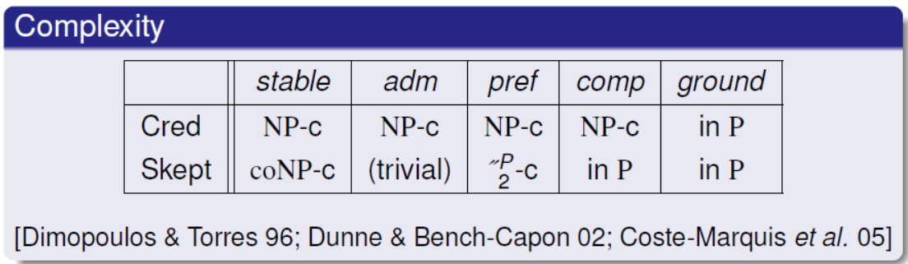The time complexity of the extensions, taken from source - [10] is as follows:

Source: [10]

As noted above, both credulous and sceptical grounded extension have a polynomial time complexity, which is better in comparison to the other three extensions being considered.

In conclusion, based on the discussion, the aim is to implement grounded extension to identify accepted arguments in debates for now, however, in the future, the plan is to have options for the other extensions as well.

## 2.7 Grounded Extension Labelling algorithm

Having reached the conclusion that grounded extension would be most suitable for the initial development. In this section, we will dive into the actual pseudo code implementation of the algorithm devised by researchers in the field.

### 2.7.1 Pseudocode

The algorithm for the grounded **extension** algorithm is adapted from source – [15]. The following is the pseudo code representation of the algorithm:

##### Input – set of arguments (A) in debate, Attack relation (R) between the arguments

##### Output – Sets containing arguments labelled as IN, OUT and UNDECIDABLE

Set IN

Set OUT

Set UNDEC

While True

For each ‘Argument’ in debate which is not already in set – IN and Out

If all attacker of ‘Argument’ is in Set OUT

Append ‘Argument’ to set IN

If at least one attacker of ‘Argument’ is in Set IN

Append ‘Argument’ to set OUT

If there has NOT been a change in set IN or OUT

Break

For each ‘Argument’ in debate which is not already in set – IN and Out

Append ‘Argument’ to set UNDEC

# 3.0 Requirements

Following on from the literature review in the previous chapter, the core requirements of the project devised based on the analysis and review coupled with supervisor’s recommendations, are as follows:

1. Based on the nature of the project, a web application solution fits well as it allows people all around the world to engage.
2. In addition, the website should be able flexible and saleable enough to be used on mobile phone browsers as well.
3. The application should allow users to register and login to their account.
4. Once the user is logged in, he should be able to create a debate topic by inputting a title and proposing an initial argument using one of the six Walton’s argumentation schemes discussed in the previous chapter.
5. Once a debate topic is created, should be visible to all other users of the website.
6. In addition, they should be able to critique the argument by proposing a counter argument, however, before doing so, he will have to base it on the critical questions of the argumentation scheme of the original argument being addressed.
7. Once the user chooses his critique point, he should be able to choose one of the 7 argumentation schemes to base his counter argument on. Once chosen, he should be able to input text conforming to the structure to make his argument.
8. Once a counter argument is made using one of the six argumentation schemes discussed. All users of the website should be able to see the counter argument proposed, displayed in the same structure as the argumentation scheme chosen.
9. Users should have to opportunity to critique the counter arguments in the same way as well. All users of the application should be able to view debate topics alongside all arguments/counter-arguments.
10. However, in order to engage in debates, they have to login using their credentials.
11. Users should have the ability to view visual representation of debate as dung’s abstract argumentation framework, in the form of directed graph. Nodes should represent the arguments in debates and arrows among them should represent attack relation, for instance, if argument A is attacking argument B, the graph should have two nodes representing A and B, with an arrow from A to B representing the attack.
    * It may be the case that when an argument attacks another, the argument attacks back as the claim being attacked is already backed by its own premises. In this case, it should be represented in the graph as bidirectional arrow between the two nodes.
12. In the visualization, users should be able to hover mouse over an argument node in the visualization to view its respective content.
13. Users should be able to jump to a sub argument in debates and subsequently critique by clicking on nodes representing arguments in the visualization.
14. The node representing initial argument should be marked clearly in the visualization.
15. At any point in debate, set of arguments to be regarded as accepted according to grounded extension labelling algorithm should be computed and the respective argument nodes in the graph visualization, should be clearly marked for the user to see. The nodes should be clearly marked to represent which arguments are ‘In’, ‘Out’ and ‘Undecidable’.
16. Users should also have the option to upvote/downvote an argument to represent its popularity. The user should be able to see votes for an argument when he hovers over the node representing it in the graph visualization.
17. The web application should have an admin side, through which argumentation schemes can be added/deleted/edited in the future. The admin side should also allow CRUD (Create, Read, Update, Delete) operations on the database.

# Specification

In the previous chapter, we had defined requirements for the project. In this chapter, we will discuss specification for each of the requirements defined.

|  |  |
| --- | --- |
| **Requirement** | **Specification** |
| **R1** | - Use a suitable web-based framework to streamline development and a clear and coherent structure across the project. |
| **R2** | - Use a suitable front-end framework which is scalable and caters towards both, websites viewed on mobile browsers as well as traditional browsers used on PC. |
| **R3** | - Use framework’s built in security and authentication libraries to implement secure user registration and login |
| **R4** | - Structure of each argumentation scheme must be stored in an SQLite database for now.  - The application has to be built in a way which allows flexibility in database engine, without requiring unreasonable amount of code changes. Hence, the schema of the database is to be abstracted using Model classes, so that the actual data retrieval code is independent of underlying database engine.  - When the user attempts to create a new debate topic, the structure of the argumentation scheme chosen is to be retrieved from the database. Subsequently, appropriate number of text field conforming to the argumentation structure is to be displayed, with appropriate header under the field, so that the user can input the respective points he wants to make in the debate  - Finally, appropriate form validation is to be configured to prevent invalid data submission. |
| **R5** | - Once the user inputs data of the initial argument, it is to be converted to a html format highlighting structure sections along with its respective content and subsequently, stored in database to be displayed in a coherent manner to other users, along with date/time of post and number of upvotes.  - The initial argument is to be stored in database as a root node of a tree. |
| **R6** | - Other users seeing the initial argument of the topic, should have the option to critique the argument.  - If he chooses to critique, we retrieve the respective set of critical questions of the argument which is being critiqued, from the database, and we allow the user to choose one the critical questions to base his counter argument on. |
| **R7** | - Once the user selects the critical question, he is to be shown a list of argumentation scheme options (retrieved from the database) to base his counter argument.  - Once the user chooses an argumentation scheme for his counter argument, the structure of the respective argumentation scheme is retrieved from the database. Subsequently, appropriate number of text input fields corresponding to the scheme will be displayed along with their respective header, to allow the user to input his argument. |
| **R8** | - Once the user inputs his counter argument according to the structure, the content is to be converted to appropriate html format to highlight the structure headings. Subsequently, the argument is to be stored in database as child node of the argument that it is critiquing. Once database is updated, it should reflect in the front-end |
| **R9** | - The counter argument is to be displayed in a text-based tree structure for others to see on the website, with indentation to make it clear which argument is attacking which. Subsequently, other users should be able to attack the new counter argument created. The specification for this is similar to the counter argument creation mentioned in R6 and R7 |
| **R10** | - Use framework’s built in authentication system to restrict permissions according to user type. (anonymous or logged in) |
| **R11, R12, R13, R14** | - Using the tree representation of the arguments in the database for a particular debate, a JSON formatted text is to be constructed, which specifies the nodes, arrows, mouse hover text and click action for the directed graph.  - Once the JSON format representing the graph is available, a graph visualization library compatible with the framework, is to be used to construct the visualization.  - Event listeners are to be implemented in nodes to enable users to jump in, on the sub argument upon clicking a node.  - Tooltips are to be implemented to display to the user the content of the argument along with its votes upon mouse hover. |
| **R15** | - Implement algorithm to extract grounded extension given data structured in a directed graph form.  - Once the labelled arguments are identified, the JSON formatted data containing specification for the graph is to be amended and the nodes according to the labelling algorithm output is to be highlighted clearly in the graph. |
| **R16** | - An upvote/downvote option is to be available for the user to vote any argument. If one chooses to upvote/downvote, we simply add the user id and the respective argument id in the database, to mark the argument as upvoted/downvoted for the user.  - The Upvote and downvote functionality is to be implemented with the help of Ajax, so the user can instantly view the updated vote count without the need to reload or refresh the page |
| **R17** | Admin site management functionality of the web development framework is to be used to automatically build the admin side of the website, which will allow administrator to modify schemes and their structure. |

# 5.0 Design

This chapter aims to provide comprehensive description of design of the system, with the help of relevant diagrams.

## 5.1 Use Case

In system design, aim of a use case diagram is to illustrate the functionalities that stakeholders expect to derive from the system. From the perspective of developers, it adds value by being a point of reference to focus on the exact functionalities to be implemented. The figure below demonstrates the ‘use case’ diagram of the project:

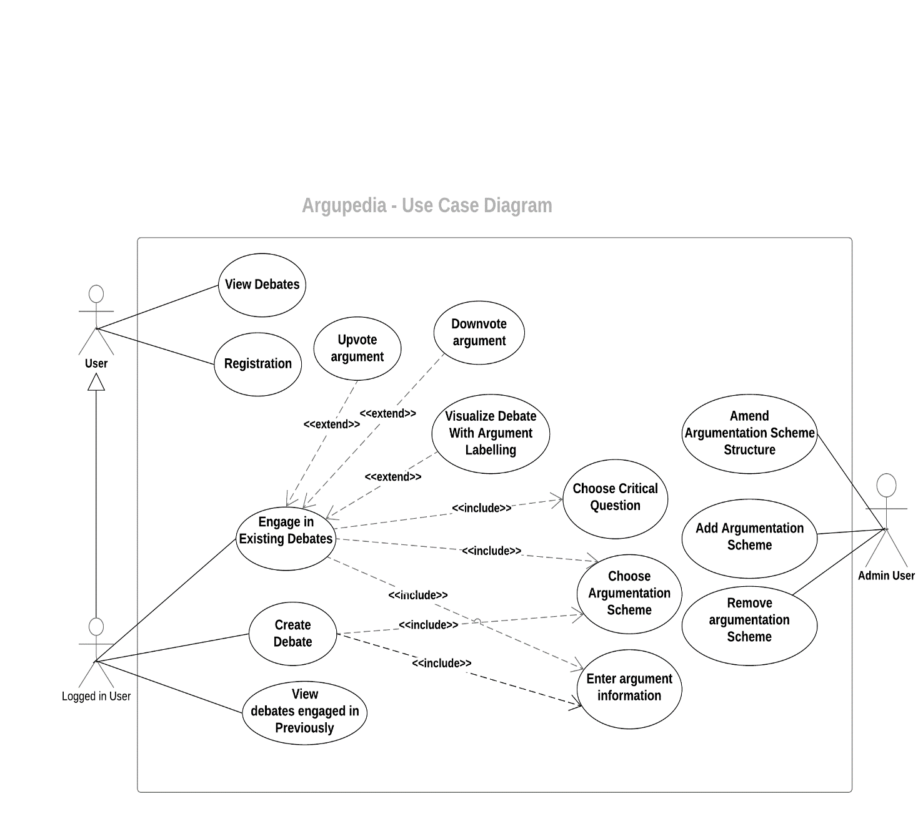The main actor of the use case is the user of the system itself and the administrator of the system as illustrated in the diagram above. Detailed description of the use cases of the system are given below:

The actor ‘User’ represents users who are not logged in, on the system. They are still able to view and explore existing debates and view their content. In addition, they are able to register themselves onto the system.

The actor ‘’Logged in User’ inherits from the ‘User’ actor. As the name implies, this represents users who are logged in, on the system. The inheritance relation denotes the fact that logged in users are able to do the same tasks as the ‘User’ actor, with added use cases.

Users logged on the system is able to view existing debates with the added ability to engage. They are able to upvote/downvote existing arguments. In addition, they are able to visualize the debate and view arguments labelled by the algorithm on the graph. Moreover, they are able to engage by critiquing existing arguments by basing their counter argument on a critical question. Furthermore, they can also create their own debate topic by providing an initial argument. Finally, they are able to view a list of existing debate topics that they had engaged previously.

On the other hand, we have the actor labelled as ‘Admin user’. As the name implies, this actor is the administrator of the system and has the privilege of accessing the administration functionalities of the system. Once logged in as administrator, he is able to change argumentation scheme structure, as well as add/remove them.

## 5.2 Project Solution Nature

A web application was designed for the project as opposed to a desktop application/mobile application nature. The justification for this decision is outlined below:

* + A web application allows greater reach in the community. It can be used by any device with a browser. Whereas, a mobile application is limited to specific mobile OS platform, such as IOS or Android. A web application can be used by a phone, as well as a laptop/desktop, as it only requires a browser.
  + An application such as this, is expected to require further updates in the future. A web application solution is perfect for this, as it simply requires the developer to update the web-site hosted on the server, with minimal inconvenience for the end user. It is difficult to push updates on mobile application, as the user may have automatic updates disabled in their respective application store.

## 5.3 Application Architecture & Justification

In this chapter, we will discuss the architecture chosen for the application and its justification.

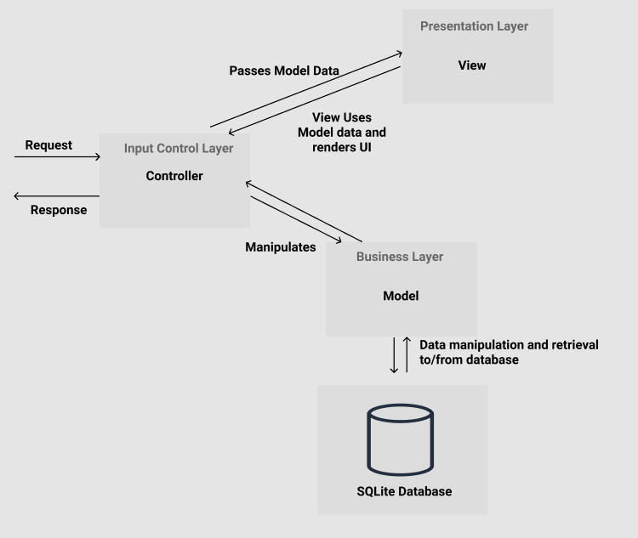Model-View-Controller (MVC) architectural pattern was chosen for the project. The primary reason for the decision was due to MVC offering excellent separability of front-end and back-end components of the system. This pattern aligns with the application's aim of optimising maintainability and reusability aspects. The following diagram provides an overview of the architecture:

As the architecture name implies, it consists of 3 distinct components, namely – Model, View and Controller. These are discussed below:

##### Model

Model is responsible for managing data of the application. It represents the application’s dynamic data structure which is independent of the user interface. In essence, database interaction of the application is abstracted through the use of models and the benefits of doing so is outlined below:

* Having an abstraction through the use of model class ensures that the data manipulation logic of the application remains autonomous and independent of the database engine. Considering the fact that requirements of a software tend to constantly evolve, having flexibility of swapping database engine in the future without having to change query logic implementation is an advantage.
* Query logic relevant to a particular database table is encapsulated within the respective model class. For instance,
  + A model class responsible for abstracting a particular database table only includes query logic which is relevant specifically to the table. For example, suppose in the database schema, we have a table called ‘Arguments’, which is responsible for storing individual argument data in a debate. In implementation, this will be abstracted through the use of a model class, namely ‘Argument’. Data manipulation logic of individual arguments – such as, retrieving upvotes, downvotes etc, will be contained and encapsulated in the ‘Argument’ class.
  + This also encourages reusability and prevents code duplication. If a particular query logic is needed elsewhere, we can just call the function in the relevant model to execute the logic. We do not have to implement it again.
  + In addition, models make it easier to follow through the data logic of the application. Suppose, we need to make a change to a particular data logic. It is easier to identify in which part of the application we need to make the change, as data logic for a specific table is located in its respective model.

##### Views

Views are responsible for the visual elements of the web application, which is presented to the end-user and it is completely independent of business logic. The advantages of a separate view component are outlined below:

* The front-end components (View) are isolated from every logic of the system including database query logic. This strengthens encapsulation and modularity of the application, aligning with quality software engineering practices.
* Having the separation enables parallel development with minimal friction. In addition, it enables developers to focus. For example, if an amendment is needed in the front-end of the application, developers is able to do so by solely focusing on front-end code and vice versa.

##### Controller

Controller is responsible for the complete orchestration of the view and the model. It is responsible for processing the request made by the client and subsequently provide response. Whenever client sends a request to the web application, the controller performs create, update, read and delete (CRUD) operations as required and passes model data onto the views, which in turn uses the model data to render the user interface as defined and returns response to the controller, which forwards response to the client via HTTP response.

## 5.4 Database Schema & Entity Relationship Model

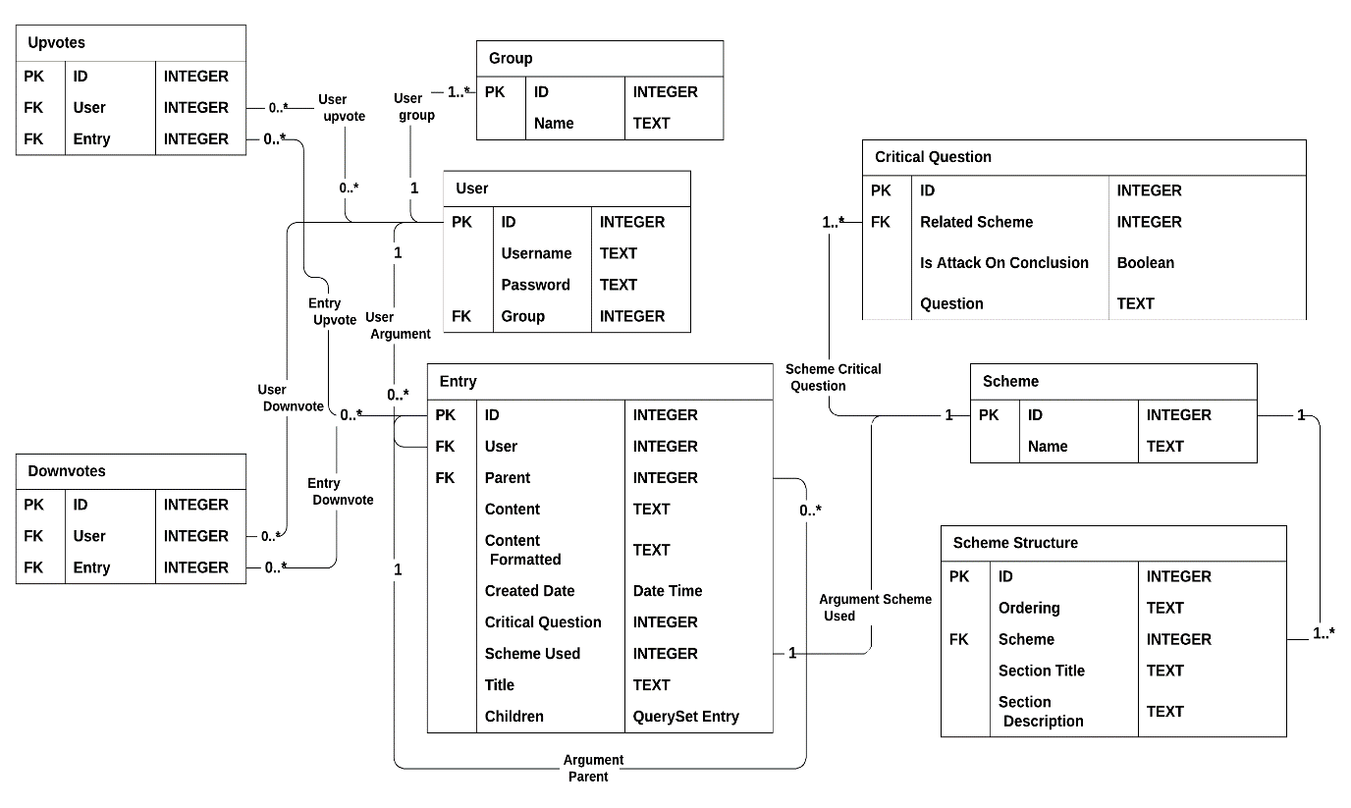Entity relational diagram is a valuable instrument for visualising the application's underlying database structure and relations between tables within. The schema was designed to minimize null values in database and according to third normal form. The diagram below demonstrates the schema of the database to be reflected using models:

The tables along with their relationship and cardinalities are described below:

* The ‘Scheme’ table contains data of the name of the argumentation schemes.
* The ‘Scheme’ table has a ‘1’ to ‘1 or many’ relation with the critical question table which holds critical question data. This relation denotes that each scheme must have at least 1 critical question
* The ‘Scheme’ table has a ‘1’ to ‘1 or many’ relation with the ‘Scheme Structure’ table which represents the headers of the scheme. For instance, the action scheme has headers – ‘in situation’, ‘taking action’, ‘achieves goal’ and ‘promotes value’, and so on and so forth. The relation denotes that each scheme, must have at least 1 header. The ‘Scheme Structure’ table holds data such as ordering of scheme headers, title, description, etc.
* ‘Group’ table contains the different groups of users of the system, such as admin, anonymous, etc.
* ‘User’ table holds data of the user of the system, such as their username, password. it a one to many relationships with the Group table. This relationship classifies whether the user is an admin or not.
* The ‘Entry’ table contains data representing atomic arguments in the debate. Structure of arguments in debates are represented in the form of tree, where the initial argument is regarded as the parent, and its children its attacker and so on and so forth. In addition, each record in ‘Entry’ table has an association with a user, to record which user has made the argument. Furthermore, it has a recursive relation with itself. This is represented in the cardinality named - ‘Argument Parent’, as shown in the diagram above. The recursive relation is used to structure debates in a tree format, as discussed.
* The ‘Upvote’ table represents a ‘many to many’ relationship between ‘Users’ and ‘Entries’ (arguments). It has foreign key associations with ‘Users’ and ‘Entries’ table to record data about which user has upvoted which entry.
* The ‘Downvote’ table, is similar to the ‘upvote’ table. It represents associations to record data about which user has downvoted which entry (argument).

### 5.4.1 Justification of Database Design

The database has been normalized to third normal form where possible.

* Note that many to many relationships are separated into a different table, containing foreign keys of the two tables being linked. This is to minimize null values in database, which is considered good practice in database design.
* In addition, each table only consists of data field relevant to their respective entity. For example, the ‘Group’ table only consists of the group name. This is to ensure that the scheme is extendable and maintainable, thus adhering to good database design principles.
  + For instance, It could have been designed in a way such that ‘Group’ would be a field/column in the ‘User’ table, however, suppose in the future, we have to store more information about ‘Groups’. If we take this approach, then this would not have been possible. Another similar example is the ‘Scheme’ table.

## 5.5 State Machine

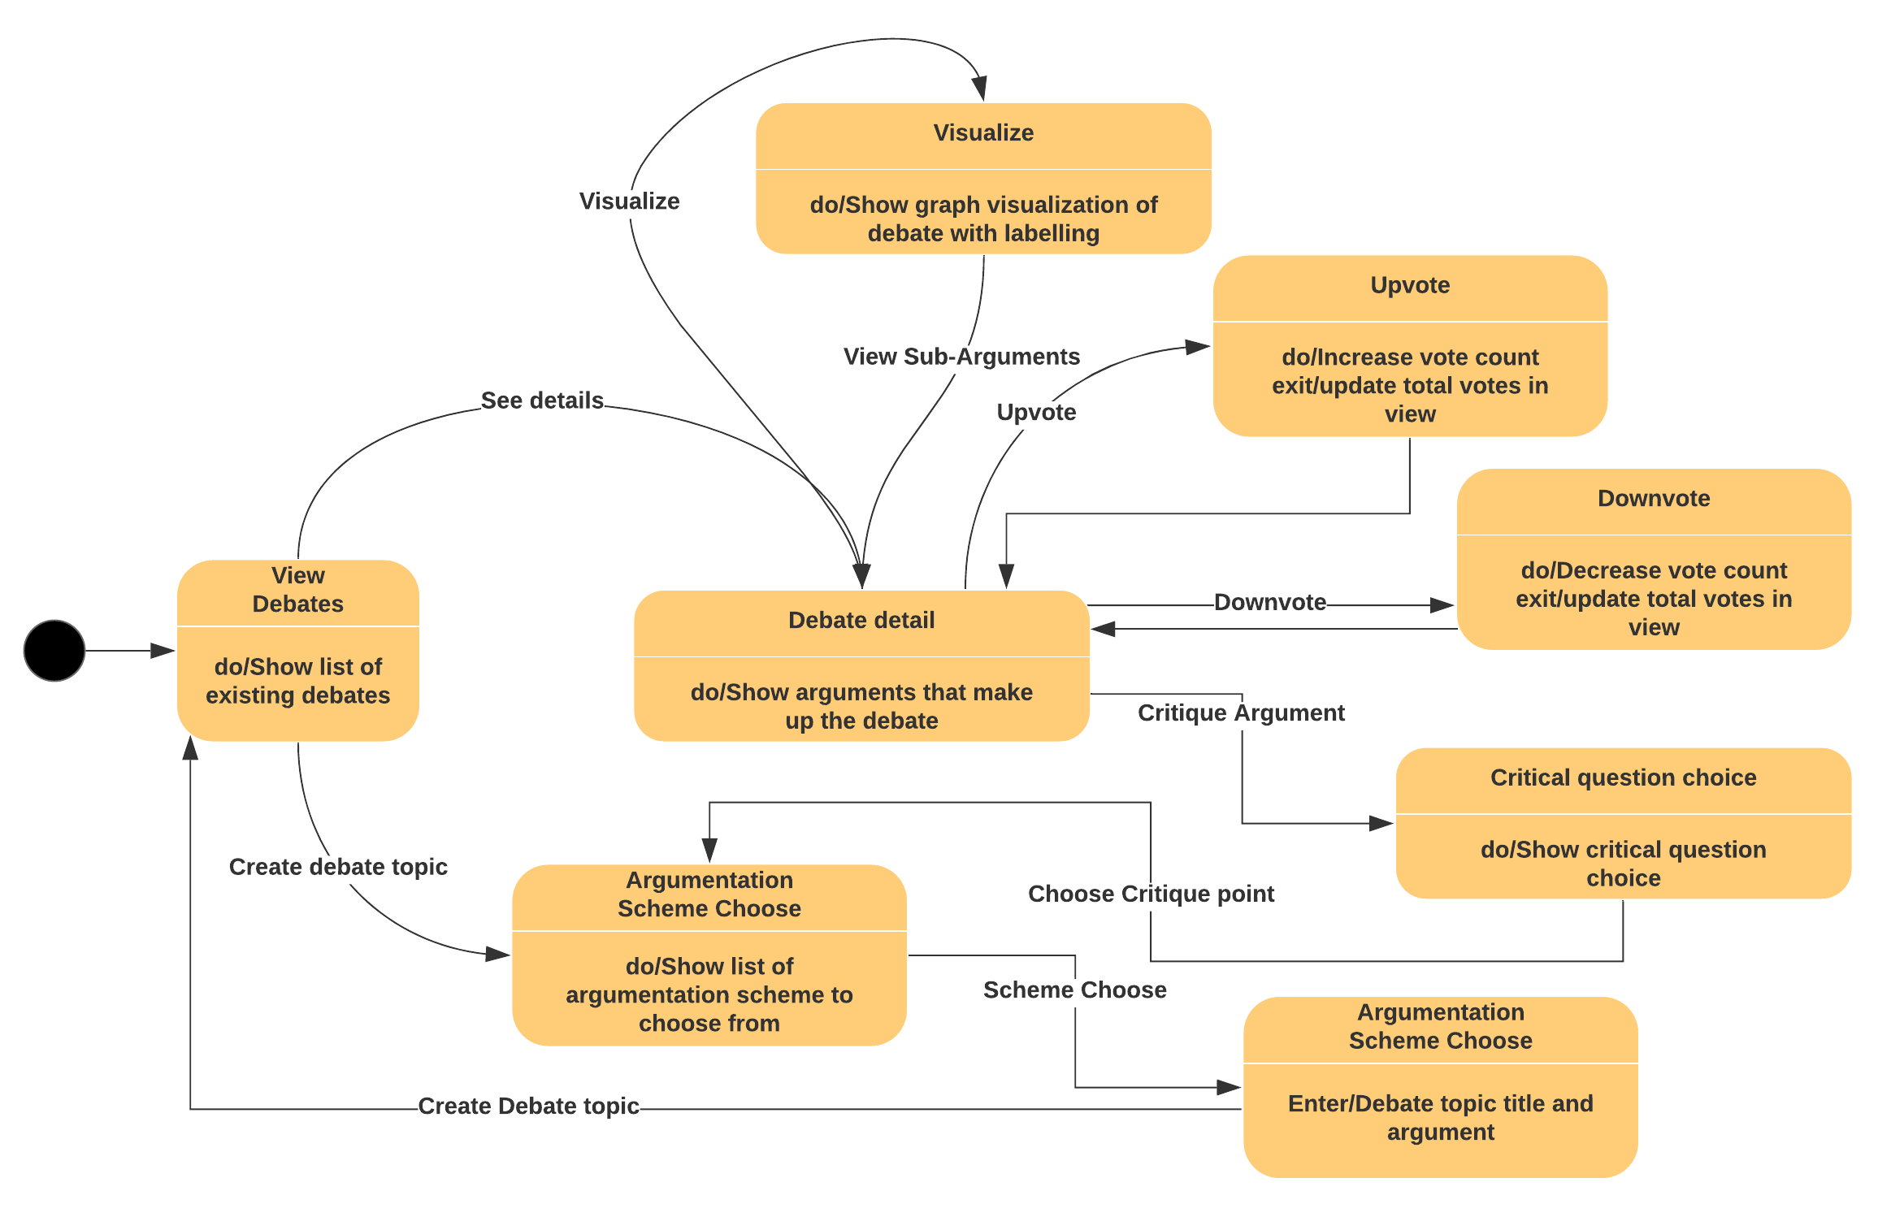State machine diagram reflects the flow of the application usage for the end user. It represents system’s various states and the triggers that cause the transition from one state to the other. The state machine diagram of the application is shown below:

## 5.6 Important Note

Please note that an agile development methodology (elaborated in the next chapter) was used for the development of the project. Hence, system design diagrams such as ‘Class diagram’ and ‘Sequence diagram’, which are very specific to implementation, was not used in the design process.

The reason for as doing so was because - setting design of classes and their interaction, in stone, would have diminished the scope of flexibility and accommodating business requirement change, which was expected to be inevitable, considering this was the initial version of the application

Therefore, to accommodate for future business requirement change based on supervisor’s feedback, design processes which are regarded as highly specific to implementation were not considered, at this early stage.

# 6.0 Implementation

In the previous chapter we discussed system design and key decisions made within along with respective justifications. This chapter aims to discuss how the design elements were incorporated and how the system was implemented overall. Initially, we will address key decision points in the implementation phase and subsequently, we will dive deeper into practical approach used to addressing the requirements and specifications defined previously.

## 6.1 Development Methodology

For the development of the project, Agile development methodology was chosen. Choosing an iterative development methodology for the project enabled having regular discussions with supervisor to ensure that the system being developed was consistent with his expectations. In addition, the preparation of different iterations of the project offered insight into important milestones of the project, which in turn enabled more efficient planning and understanding of scope. Moreover, it enabled more flexibility in accommodating changes in the application based on supervisor feedback.

## Key Implementation Decisions

Applications are prone to even evolving demands. It is for this reason, maintainability and extendibility were among key factors - driving decisions made during implementation. In this section, we will discuss decisions made with regards to implementation of the project and their respective reasoning in support.

### 6.2.1 Development Framework & Technologies

As stated in the requirements chapter, a web application solution is more in alignment with the nature of the problem. In order to ensure efficient development of the project, decision was made to use ‘Django’, a python-based web development framework.

Django provides full set of benefits that come with using typical web development frameworks, such as efficiency, scalability and code-reusability. An overview of the justifications for choosing Django framework specifically for the development of this project is outlined below:

* Django provides authentication library which allows developers to implement industry standard security measures in the application. Some examples of essential security measures provided by Django is listed below:
  + Cookie encryption for sessions.
  + Cross Site request forgery (CSRF) attack protection.
  + Cross site scripting (XSS) protection.
  + SQL Injection protection
  + Host header validation
* It enforces Model View Controller architectural pattern (discussed in the Design chapter) which leads to excellent modularity of different components of the application.
* It abstracts database layer of the application through the use of Object Relational Mapping via Django Models, allowing flexibility in switching database engine in the future without major code changes in database logic, thus making the application database engine independent.
* It also allows easy and automatic management of admin side of the website along with automatic synchronization with changes in model, which gives Django an edge over other similar web application development frameworks in the industry.
* Provides error handling services for web application, including but not limited to displaying or appropriate error codes in case application runs into issue.

Considering the above-mentioned advantages of using Django framework, coupled with excellent community support of python as a programming language, the decision was made to use Django for the project.

### 6.2.2 Database Layer

The data layer of the application was implemented according to the architecture discussed in the design chapter. Underlying database engine used was Django’s default - ‘SQLite’, however, the implementation was done using Django models, which allows implementation to be completely independent of database engine. This is illustrated below:

#### Model Classes

Model classes were used to represent the database schema, visualized by ‘Entity relational diagram’ in Design chapter. Models are defined in the ‘models.py’ file located at – ‘/Argupedia’. A code snippet of the project demonstrating model of the ‘Entry’ table in the schema, as an example, is shown below:

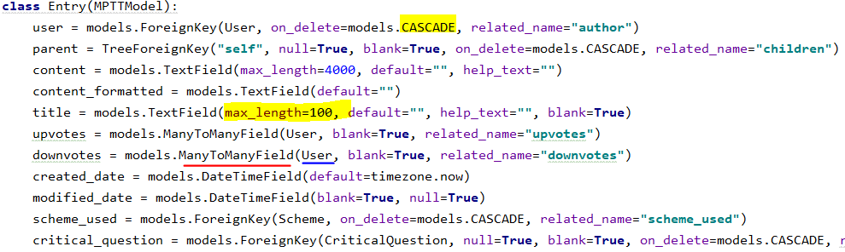

As demonstrated in the snapshot above, models define database fields of a table in a readable manner. For example, it is clear from the code snippet that the user foreign key relation has a ‘cascading relation’ and that the max length of title of an argument is 100 characters, as shown in the yellow highlighted area. In addition, foreign key relations are easy to understand at a glance as well. For example, in the ‘red’ underlined part in the snapshot above, we can easily know at a glance that the entry table has a field named ‘downvote’, which has a many to many relation with the ‘User’ model.

#### How models were implemented to provide value

As discussed in the previous section, the use of model provides representation of database in a simple, readable and easy to understand manner, which aligns with good software engineering principles. On the other hand, if raw SQL query was used to define the schema, then this would have been complete opposite. In our case, by simply looking at a model class, the developer is able to figure out almost everything about the entity. Furthermore, if change is needed at a database entity, it is easy to figure out where to make the change as logic related to each database entity is confined within the respective class.

Moreover, models play a significant role in reducing code duplication via methods implementing query operations. Query functions related to a particular entity in the database is confined/encapsulated within the respective model. the snapshot below shows an example method from the Entry (argument) model class, which calculates total votes of an entry (argument).

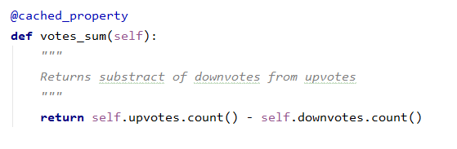

Note that the operation carried out by the method shown above (calculates total vote count for an argument) relates to argument entity, hence it is encapsulated within the Entry (Argument) model. In addition, the method shown in the example above can be called within any argument (entry) object to retrieve its total vote count. Therefore, the implementation promotes reusability which aligns well with software engineering principles.

Furthermore, Django’s built in object relational mapper (ORM) is used to interact with the database models. This allows us to perform data retrieval tasks without having to write complex SQL queries. An example code snippet demonstrating use of ORM is shown below:

The code snippet above retrieves structure of the scheme being passed in and orders them. It is worth noting that the code is significantly more concise and self-explanatory, when compared to raw SQL queries.

### 6.2.3 Presentation Layer (Front-end)

The front-end implementation of the application reflects the architecture diagram demonstrated in the design chapter. Templates/Visual-elements (HTML files) to be presented to the end user are confined within ‘templates’ package in the project and are completely separate from all business logic of the application.

#### Using template language to ensure front-end logic is easy to maintain

Django template language was used for implementing logic for the front-end components. Using template language ensures that there is no mixture between HTML and raw python code used for business logic. As a result, it allows separation between front and back end components. Finally, it allows implementation of front-end logic by writing code which is clear, concise and significantly for readable, thus making the logic easier to maintain in the long run. This is demonstrated in the example below:

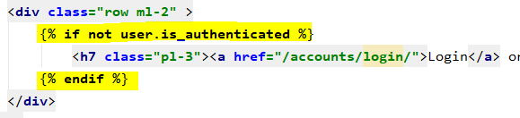

Note that the front-end code logic (highlighted in yellow), is self-explanatory and very easy to follow and understand. As a result, developers revisiting code in the future would require significantly less effort to get an overview of the logic.

***Cohesive directory structure of front-end components***

Front-end components of the application were into separate folders, each containing templates representing their own respective area. This is to make the directory structure more cohesive. This is directory structure of templates are demonstrated below:

* ‘/templates’
  + Contains front-end templates relevant for the general application, e.g.: Authentication templates such as login/registration page
* ‘/argupedia/templates’
  + Contains front-end templates specific to ‘Argupedia’ application, for instance, graph visualization page.

In the future, it is expected that as the application expands its feature set, templates will be further divided into more directory structure according to area of the application.

***Preventing code duplication in front-end using template engine***

Code snippets in the front-end which have high reusability scope are split into separate files, so that in the future, if we have to use it elsewhere, it can simply be included in the template, without having to reimplement it. This eliminates code duplication in front-end components of the application. Reusable code snippet of front-end are located in the directory – ‘templates/components’. This is further illustrated below:

As shown on the snapshot on the left, the directory contains the file ‘navbar.html’. This file only contains code concerning the navigation bar of the web pages.

If we have to change the navigation bar, we can just make the changes here and it would affect the entire application. This makes the code more maintainable and extendable and if changes are needed, we only need to change confined in a single file.

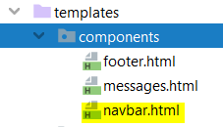

***Improving maintainability in front-end layouts***

Furthermore, a single cohesive layout has been set up for web-pages across the application. The front-end has been set up, such that it uses the same layout for consistency. This is further illustrated below:

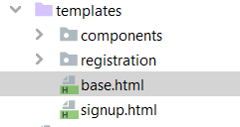

The ‘base.html’ file (shown on the left) defines a consistent layout of webpages

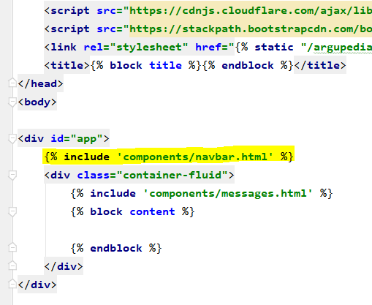

The snapshot on the left, shows content of the layout file.

Note that it includes code which sets up the HTML tag layout of the page. If this layout is included in the pages, then we do not have to duplicate the code already written.

It also includes the navbar component (code snippet discussed previously), so it reflects across all pages

Finally, the snapshot below demonstrates the layout being included in a template file (HTML). Doing so, eliminate the need to set up the layout of the page again. This not only minimizes code rewriting, but also makes it easier to maintain - as if change in layout is needed, we only make to make changes at a single point.

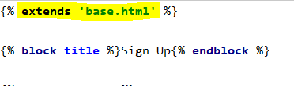

### 6.2.4 Routing Implementation

To improve code cohesiveness and adhere to strong software development standards, Django’s routing component was used to process URL requests. The routing component is located at – ‘/argupedia/urls.py’

The routing component match URL of request made by the user’s browser and forward to appropriate function in controller, depending on whether the request is of type – HTTP GET or HTTP POST.

#### Benefits of having separate routing component

The following are the key driving decisions behind having a separate routing component:

* Routes provide a single point of contact for URL requests and maps them to controllers. If the single point of contact did not exist and URL mappings were scattered throughout different parts of the application, then it would be very challenging to maintain. Thus, having routes package improves maintainability.
* Routes also define valid URLs of the website. As a result, developers can simply have a look at the routing component to an overview of URL’s considered as valid for the website. This also helps debug during development.

An example code snippet from the routing component is illustrated below:

Valid URL and its parameter type defined

Controller class on which too route request

Method to call in controller class to handle the request

Name of the route

### 6.2.5 Controller Implementation

As quoted [23] in Django documentation, ‘View’ represents how the data is presented to the end-user and not necessarily how it looks. ‘Views’ in Django reflects the role of traditional controllers in MVC architecture. These classes are located in – ‘/argupedia/views’. In this section, we will discuss how these are implemented.

As discussed in the previous section, requests coming in from the browser are handled by the routing component, which in turn forwards it to the appropriate controller. The controller then handles the logic of the request.

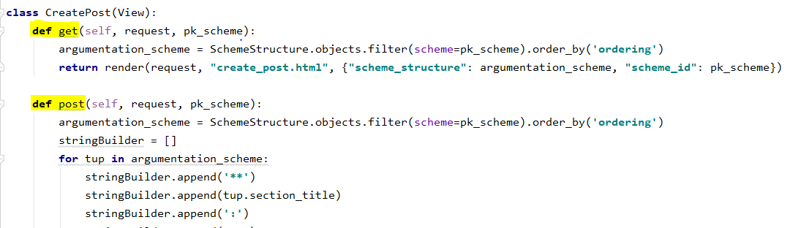

The snapshot above demonstrates a controller class implementation. Note that it has 2 methods – namely ‘get’ and ‘post’, which as its name implies, performs operations based on whether the request routed by the routing component is of type HTTP – Get or Post. In the end, the views sends render request to Django’s template engine along with data from the models required for the view and subsequently, an updated web-page is displayed to the end user.

### 6.2.6 Styling Implementation

Key driving decision behind the user interface of the application involved consistency, scalability (across different devices) and last but not least – ease of use. This section aims to discuss the key decisions taken – with regards to styling and user experience across the application.

#### Styling framework

Bootstrap has been known to be a highly efficient and scalable front-end framework in the industry. Its version - 4.3.1 (latest release at time of writing), was used to implement the front-end of the web application. The key driving decisions for doing so are as follows:

* Bootstrap’s responsive CSS adjusts to phones, tablets, and desktops, as a result it provides a consistent look and feel across different devices.
* In addition, it is compatible with all modern browsers (Chrome, Firefox, Internet Explorer, Safari, and Opera), including their mobile alternatives.

#### CSS Styling Unification

CSS styling of web-page components across the entire application is unified in a single CSS file (located in – ‘/argupedia/static/argupedia/styles.css’) and have referenced user interface components in the application via their respective id.

* Therefore, if styling of a specific component has to be changed, for example - buttons, then, only styling code for button attribute in the CSS file has to be changed. Doing so will ultimately reflect across all buttons in the entire application for consistent look and feel. This achieves good maintainability of front-end of the application.

## Implementation of Requirements

In this section, we will discuss how the requirements defined in chapter 3 were implemented and what approach was taken and why.

#### R1 & R2 - Foundation of web development & front-end

These requirements were implemented as discussed previously in the chapter. To re-iterate - Django framework was used to build the web application coupled with Bootstrap framework for the front-end.

#### R3 - Security

In order to implement secure login and registration, Django’s built in authentication set-up tool was used. By running the ‘superuser’ create command in Django console, login and registration was set up. Subsequently, the templates (HTML) of the login and registration pages were redesigned using the layout defined to achieve a consistent user experience.

#### R4 – Allow structured input to argument by user based on scheme chosen

In order to implement secure login and registration, Django’s built in authentication set-up tool was used. By running the ‘superuser’ create command in Django console, login and registration was set up. Subsequently, the templates (HTML) of the login and registration pages were redesigned using the layout defined to achieve a consistent user experience.

# Bibliography

[1] Statista (2019, November 20). Reddit - Statistics & Facts [Online]. Available: https://www.statista.com/topics/5672/reddit/

[2] Ginny Marvin (2018, September 17). Quora introduces Broad Targeting, says audience hits 300 mil-lion monthly users [Online]. Available: https://marketingland.com/quora-introduces-broad-targeting-says-audience-hits-300-million-monthly-users-248261

[3] Amazon (2019, December). The top 500 sites on the web [Online]. Available: https://www.alexa.com/topsites

[4] Atkinson K, Bench-Capon T, McBurney P. PARMENIDES: facilitating deliberation in democracies. Artificial Intelligence and Law. 2006 Dec 1;14(4):261-75.

[5] SubReddit Stats (2019, December 4). Changemyview Stats [Online]. Available: https://subredditstats.com/r/changemyview

[6] Karin Osvaldsson, “Bullying in Context: Stories of Bullying on an Internet Discussion Board,” Dept. of Child Studies, Linköping University, 2011

[7] Plous Scott. The psychology of judgment and decision making. Mcgraw-Hill Book Company; 1993.

[8] Van Eemeren F, Van Eemeren FH, Grootendorst R. A systematic theory of argumentation: The prag-ma-dialectical approach. Cambridge University Press; 2004.

[9] Dung PM. On the Acceptability of Arguments and its Fundamental Role in Nonmonotonic Reasoning and Logic Programming. InIJCAI 1993 Aug 28 (Vol. 93, pp. 852-857).

[10] Gerhard Brewka, Class Lecture, Topic: " Handling Exceptions in Knowledge Representation: A Brief Introduction to Nonmonotonic Reasoning”, Computer Science, University of Leipzig, Leipzig, May 2017

[11] Caminada M. A gentle introduction to argumentation semantics. Lecture material, Summer. 2008.

[12] Baroni, P., Caminada, M. and Giacomin, M., 2011. An introduction to argumentation semantics. The knowledge engineering review, 26(4), pp.365-410.

[13] Peter McBurney, Class Lecture, Topic: "Lecture 7: Argumentation I”, Computer Science, King’s College London, London, November 2019.

[14] P. M. Dung, “On the acceptability of arguments and its fundamental role in nonmonotonic reasoning, logic programming,” Division of Computer Science, Asian Institute of Technology, 1995.

[15] Modgil S, Caminada M. Proof theories and algorithms for abstract argumentation frameworks. In Argumentation in artificial intelligence 2009 (pp. 105-129). Springer, Boston, MA.

[16] Dagan I, Dolan B, Magnini B, Roth D. Recognizing textual entailment: Rational, evaluation and approaches–erratum. Natural Language Engineering. 2010 Jan;16(1):105-.

[17] Cabrio E, Villata S. Combining textual entailment and argumentation theory for supporting online debates interactions. In Proceedings of the 50th Annual Meeting of the Association for Computational Linguistics (Volume 2: Short Papers) 2012 Jul (pp. 208-212).

[18] Walton D., “Chapter 3: Argumentation Schemes” in Fundamentals of critical argumentation. Cam-bridge University Press; 2005 Oct 31.

[19] Walton D, Reed C. Argumentation schemes and defeasible inferences. In Workshop on computation-al models of natural argument, 15th European conference on artificial intelligence 2002 Jul 22 (pp. 11-20).

[20] Live Science (2017, July 25). Deductive Reasoning vs. Inductive Reasoning [Online]. Available: https://www.livescience.com/21569-deduction-vs-induction.html.

[21] Atkinson, K., Bench-Capon, T. and McBurney, P., 2006. PARMENIDES: facilitating deliberation in democracies. Artificial Intelligence and Law, 14(4), pp.261-275.

[22] Atkinson KM. What should we do? Computational representation of persuasive argument in practical reasoning.

[23] Django FAQ General (2020, April 01). Available: https://docs.djangoproject.com/en/3.0/faq/general/#django-appears-to-be-a-mvc-framework-but-you-call-the-controller-the-view-and-the-view-the-template-how-come-you-don-t-use-the-standard-names